Home Visit Movement How-To Guide
Navigating to the Home Visit Movement Portal:
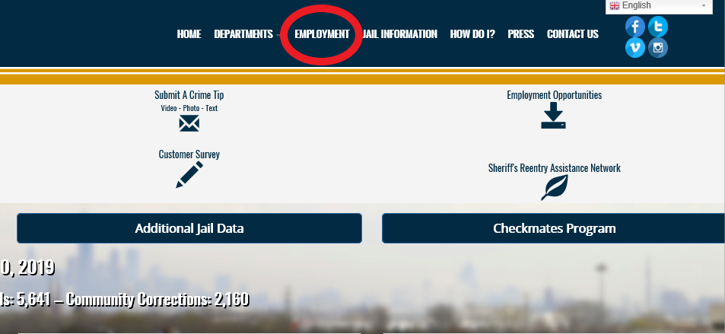
- Please visit https://www.cookcountysheriff.org/ and select the Employment tab highlighted above
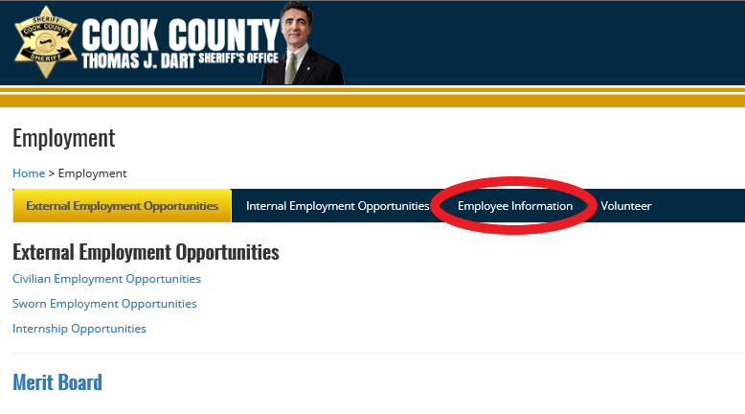
- In the Employment Section please select the Employee Information highlighted above
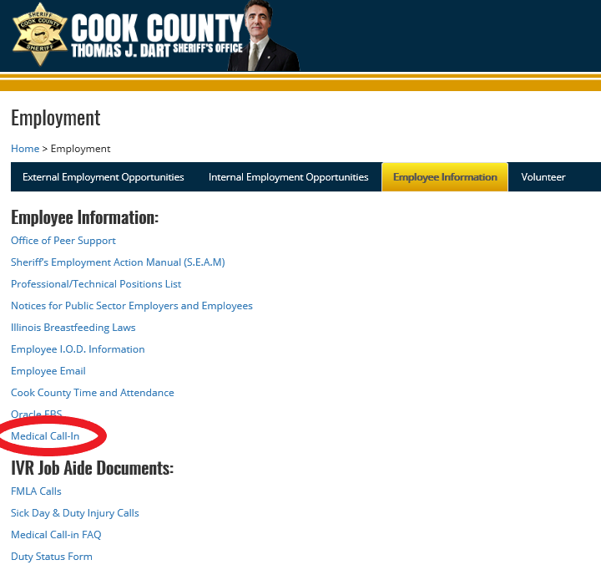
- Once in the Employee Information Section, select the Medical Movement section highlighted above

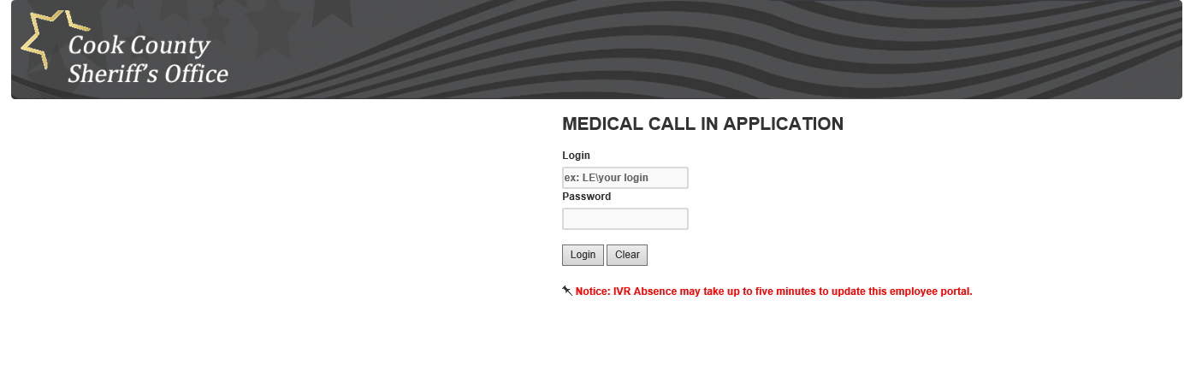

- On this screen please enter your LE login and password to access your medical movement portal
- This is the same information used to login to your CCSO computer
- The LE\ is already present and there is no need to enter this information
Navigating the Movement Portal
Once logged into the portal, please follow these steps to input your medical movement:
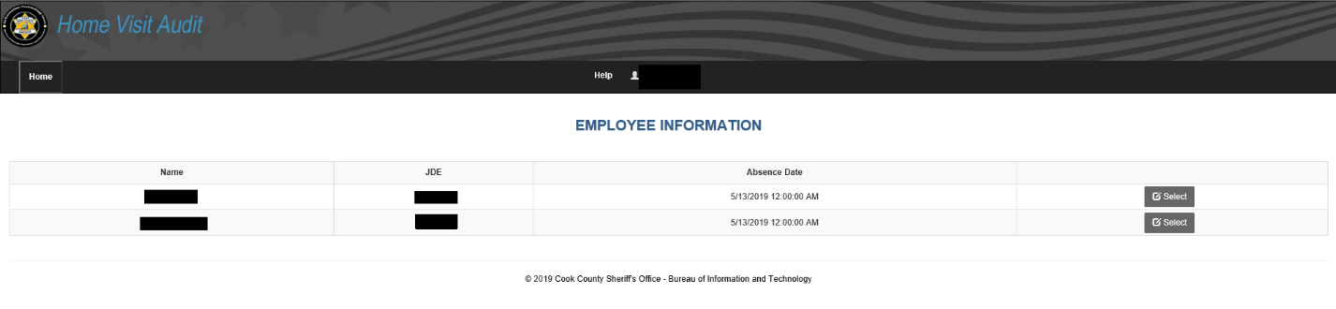
- In the above screen:
  - IF you have multiple call-ins for multiple days your login screen will look like this. Please SELECT the appropriate day you would like enter movement for
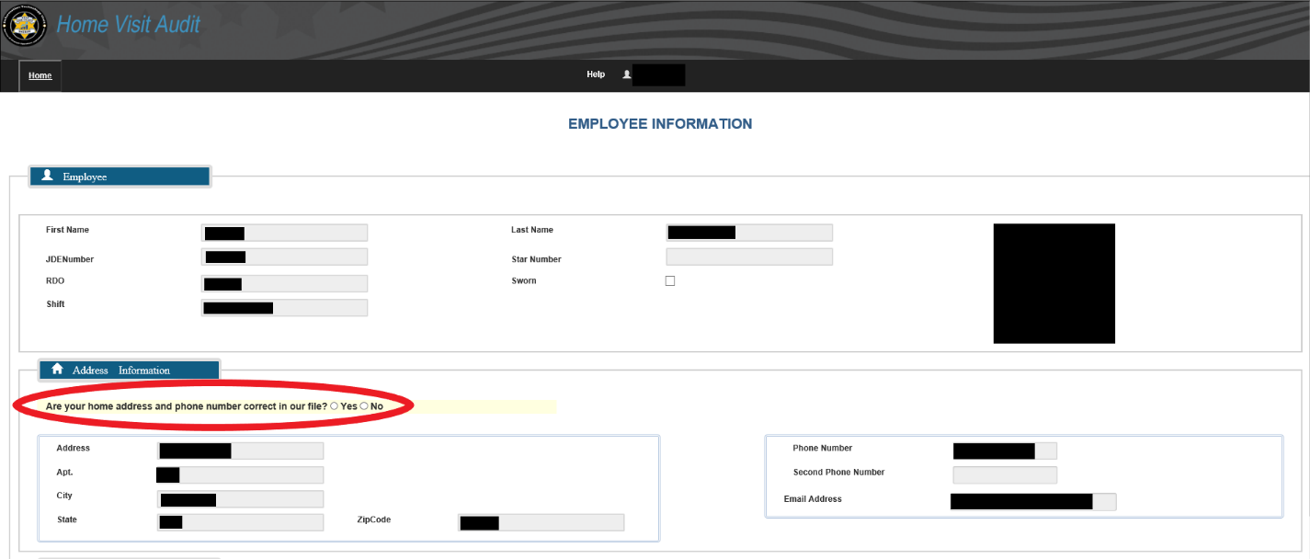
- Once the appropriate date has been selected, you will be directed to the above screen
- Please review and confirm if your home address and phone number are correct.
  - If they are correct, please select YES in the highlighted section
- If the information is incorrect, please select NO in the highlighted section
  - If NO, a new section will appear for you to enter your updated address and phone number
    - THIS IS A ONE TIME CHANGE AND WILL NOT UPDATE ORACLE EBS. AFTER THIS MOVEMENT ENTRY IS COMPLETE, PLEASE ACCESS ORACLE EBS TO UPDATE YOUR INFORMATION.
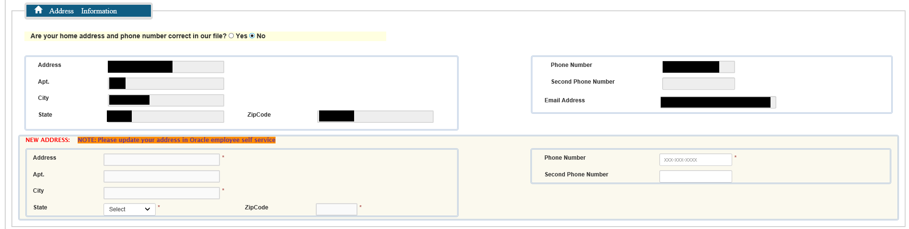
- After your address and phone number have been confirmed, please scroll down to the AVAILABILITY section
  - If you will be home all day, select YES in the highlighted section
  - If you will not be home all day, select NO in the highlighted section
    - If NO is selected, please select the ADD ALTERNATIVE LOCATION button for a new section to appear and prompt you to input your alternative address(es)
    - Select ADD ALTERNATIVE LOCATION
      - Multiple addresses can be entered in this section to cover multiple movement during your shift
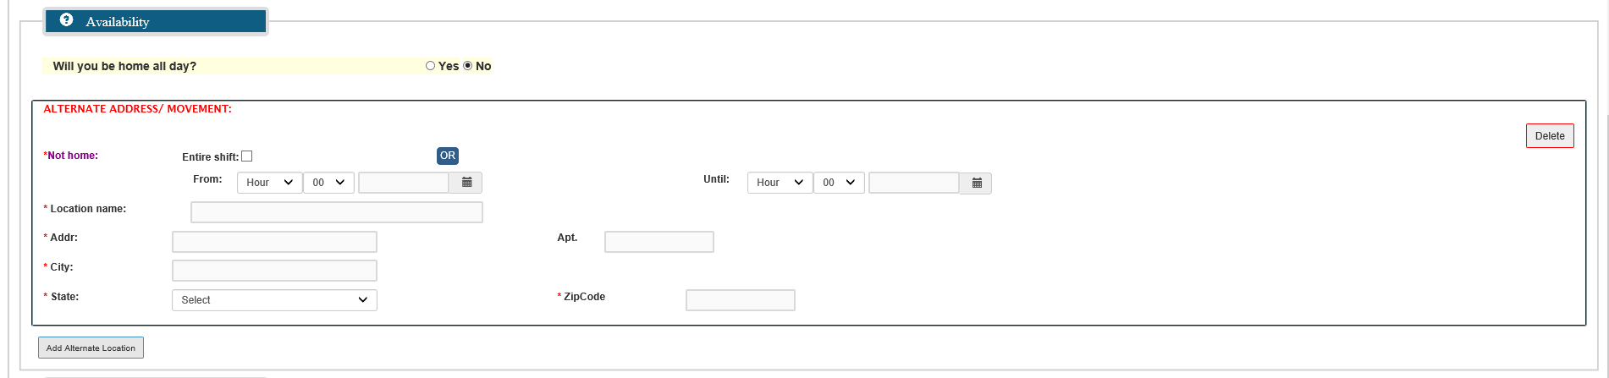
- In this section, please enter the following information for each movement:
  - Timeframe, location name, address, city, state and zip code for your alternative location
    - If you will be at a specific location for the duration of your shift please select Entire Shift

- ONCE A MOVEMENT HAS BEEN SAVED, IT CANNOT BE EDITED OR DELETED. TO CORRECT A MISTAKE, PLEASE CREATE A NEW ENTRY WITH THE CORRECT INFORMATION.

- If you have any additional notes, you can enter those in the following section:
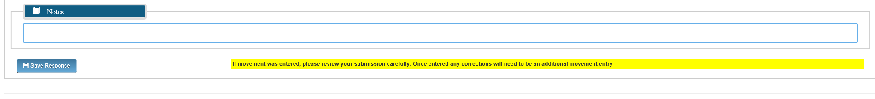
  - Once you have reviewed the information and confirmed everything is correct, please select SAVE RESPONSE to save your movement and send to the home check team automatically
- Once the record has been saved, the following screen will appear:
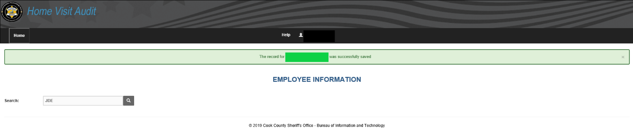
- To access your information again, please use the SEARCH function to search your JDE
  - This will redirect you to your Medical Movement record(s) to input more movement

